**Palo Alto factory reset**

Derek Liu Cybersecurity Period 5

Lab #1

**Factory Reset Palo Alto Firewall***Derek Liu*

Purpose

To become familiar with Palo Alto firewalls and basic skills required for configure it.

Background Information

When accessing a new Palo Alto firewall or if you are unsure of the condition that the firewall is in, it is best practice to factory reset it before configuring it. In this lab, we got used Palo Alto firewalls and the first step was to factory reset it so we could access it and configure it from scratch.

Configurations

Step 1.

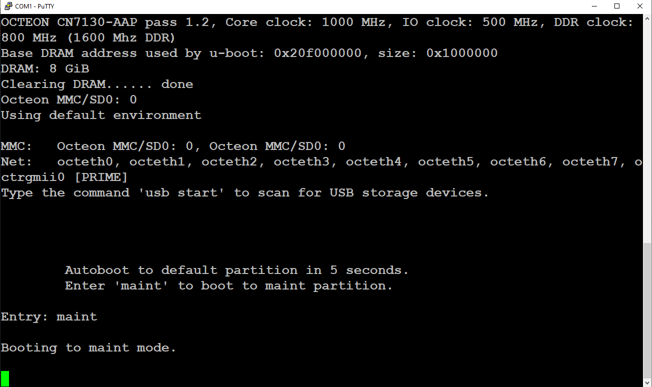

Console into the firewall using the console port. Wait for boot up text to finish. Type in “maint” to enter maint mode.

Step 2.

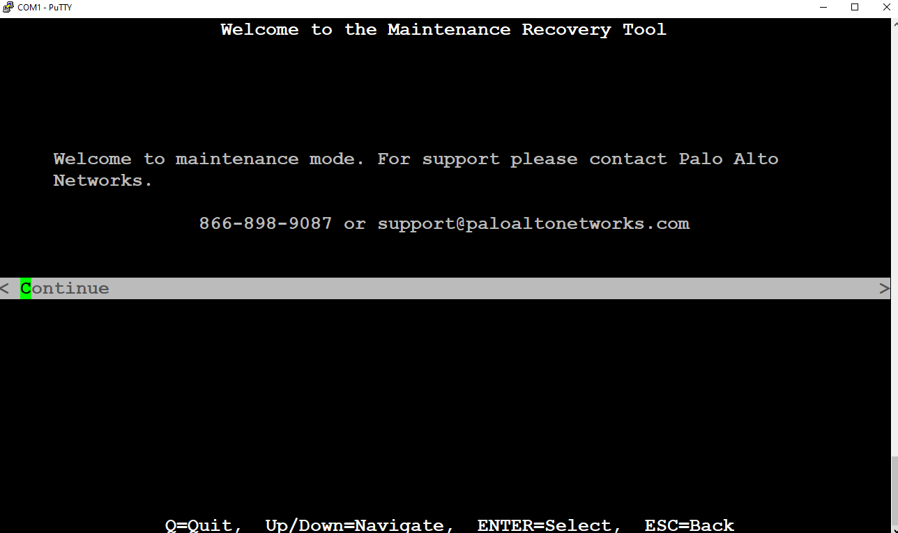

This is what the terminal should show after entering maint mode. Hit continue to continue.

Step 3.

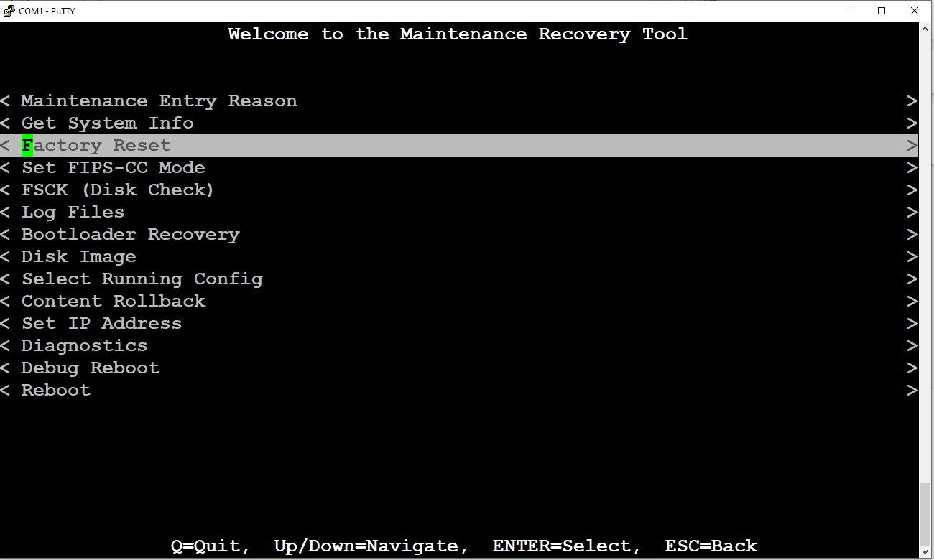

Scroll down to Factory Reset and press enter to select. This should be following screen:

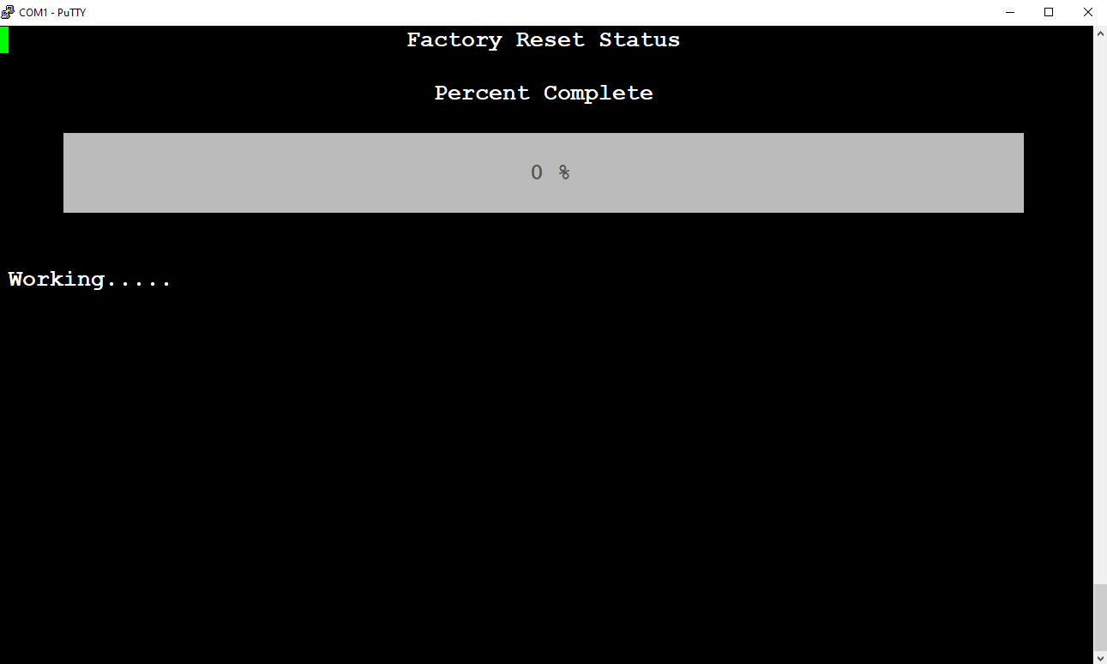

Step 3.

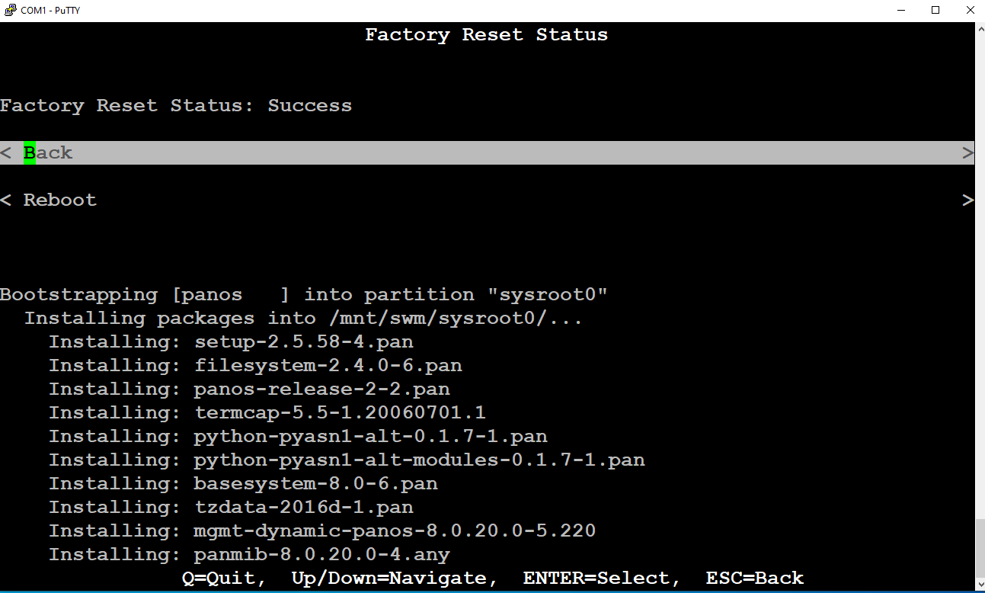

After it finishes factory resetting, select reboot and go through the startup text again.

Step 4.

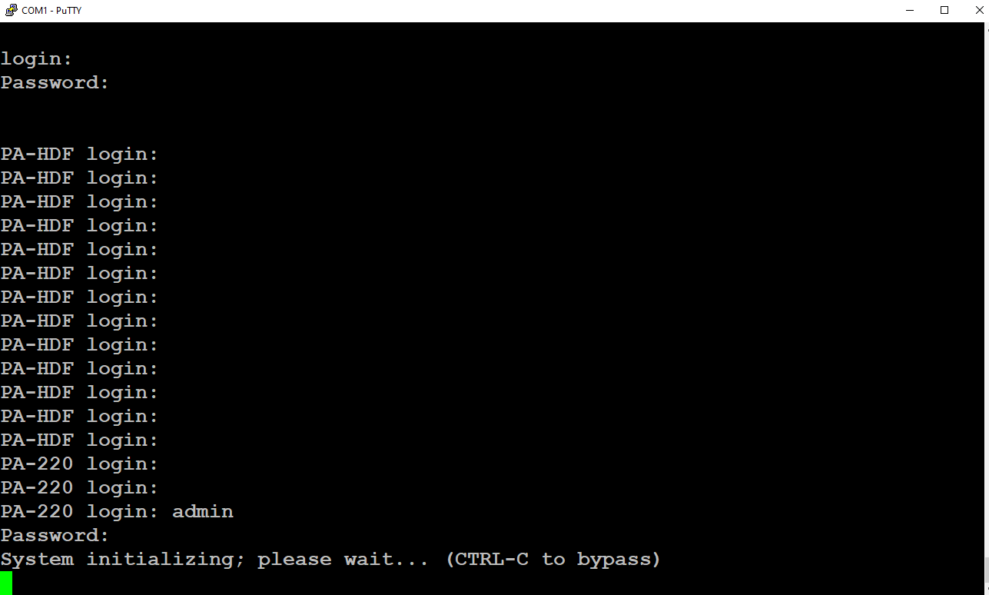

The default username and password are admin and admin respectively. But before being able to type in the username and password, the firewall needs to switch its prompt from “PA-HDF” to “PA-220”. Typing in admin and admin during PA-HDF will not let you in.

Problems

When figuring out when to type in “maint” at the beginning, we often were too late the first time. We learned that “maint” could be typed in during the startup text and still enter maint mode. After entering maint mode and clicking factory reset, we were unsure if the factory reset went through so we rebooted it. The firewall should be factory reset after finishing the startup dialog. Initially after trying to enter the username and password of “admin” and “admin” we couldn’t get into the firewall since errors kept appearing. The solution was to wait until the prompt turned from “PA-HDF login:” to “PA-220 login:”.

Conclusion

In this lab, we obtained a used palo alto firewall 220. We used a pc with a console cord to console into the firewall to enter maint mode. From maint mode, we factory reset the firewall so that we can configure it in the future.